**Project name:**

***The Rain sensor***

**Team Members:**

***Maaz***

***Hamid***

***Danyal***

**Submitted To:**

***Haseen Ullah Jan***

**Team Name:**

**DHM**



**University of Engineering and Technology, Peshawar**

**Department of Computer System Engineering**

**Apparatus:**

* Frame
* Battery
* Bread Board
* LEDs
* Connecting wires
* Switch
* Buzzers
* Rain sensors

**Let’s see the functions and uses of each apparatus;**

* **Frame:**

**It’s a model (House) in which we setup all the required items.**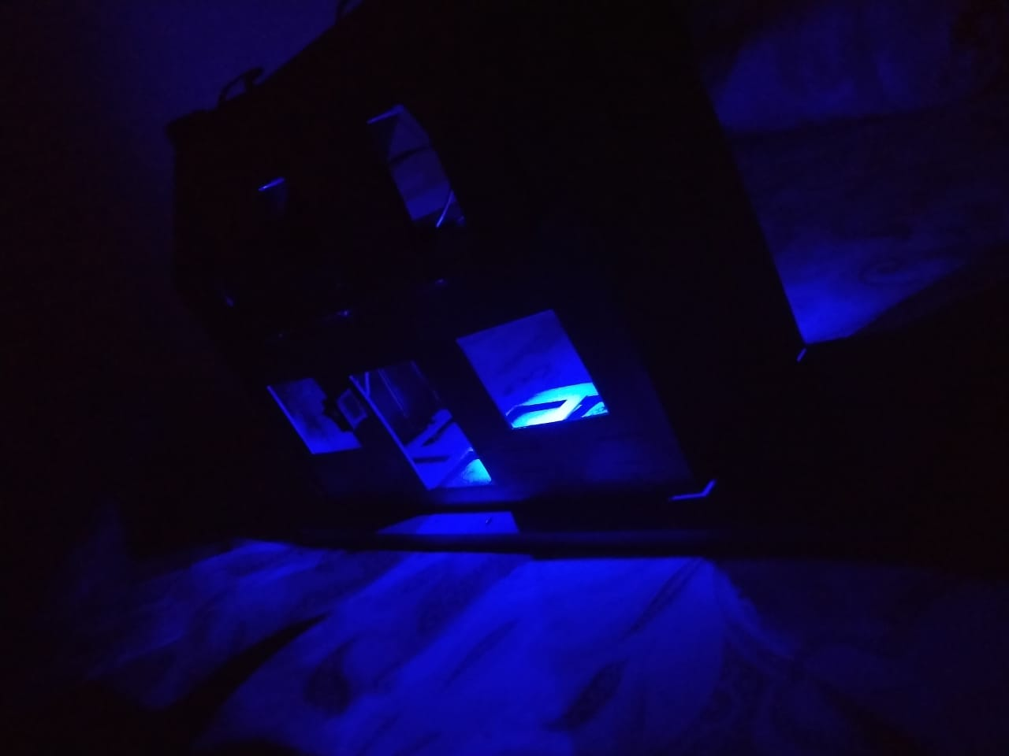

* **Battery:**

In this project we are using a 9V battery, which is connected in bread board.

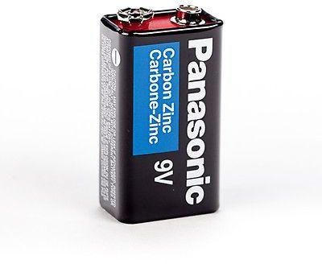

* **Bread board:**

A board for making an experimental model of an electric circuit. It helps us connect different wires in creating a circuit. A breadboard is a rectangular board with many mounting holes. They are used for creating electrical connections between electronic components and single board computers. The connections aren't permanent and they can be removed and placed again.

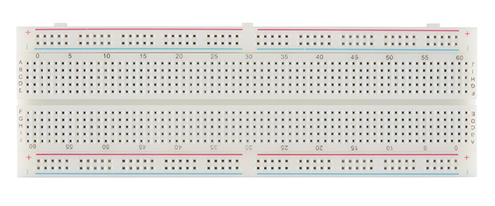

* **LEDs:**

A light-emitting diode (a semiconductor diode which glows when a voltage is applied). They come in many different colors and sizes. We used blue LEDs in our project.

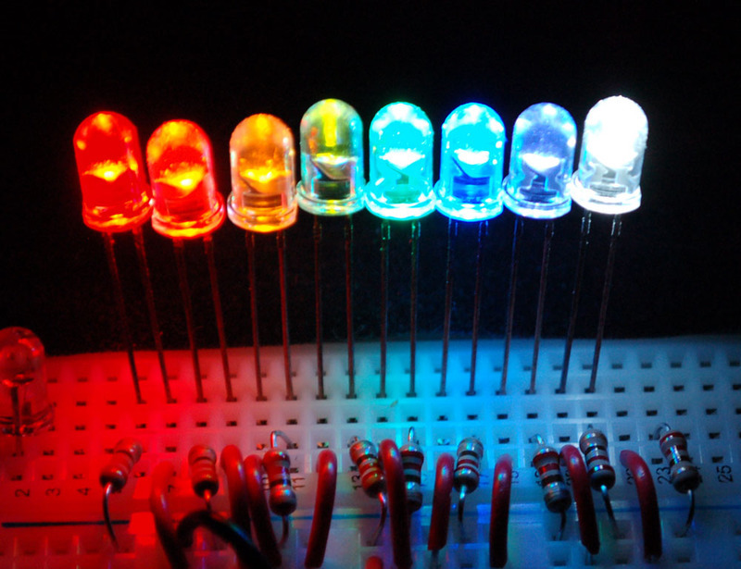

* **Connecting wires:**

These are the wires used to connect the sensors, battery, LEDs and buzzers all together. It’s the basic wires for connection usage. A wire is a flexible strand of metal, usually cylindrical. Wires are used for establishing electrical conductivity between two devices of an electrical circuit. They possess negligible resistance to the passage of current.

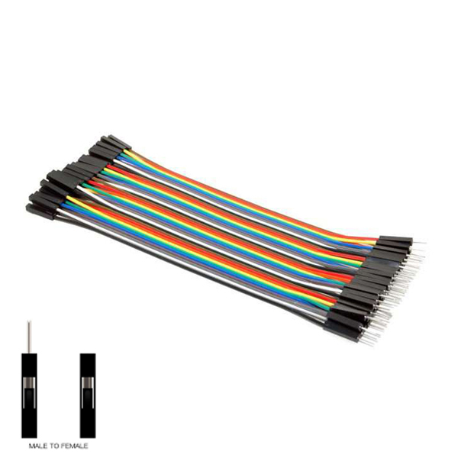

* **Switches:**

**Switches** are key building blocks for any network. They connect multiple devices, such as computers, wireless access points, printers, and servers; on the same network within a building or campus. A **switch** enables connected devices to share information and talk to each other.

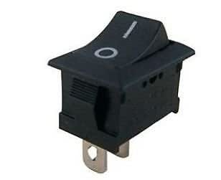

* **Buzzers:**

A buzzer or beeper is an audio signaling device, which may be mechanical, electromechanical, or piezoelectric (piezo for short). Typical uses of buzzers and beepers include alarm devices, timers, and confirmation of user input.

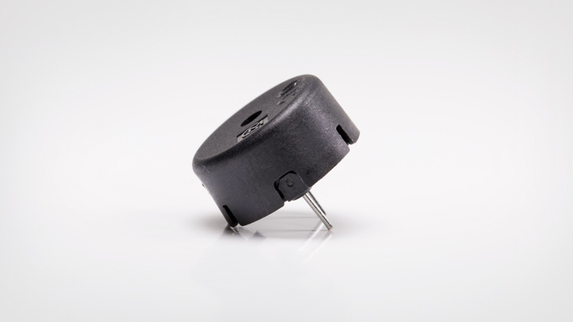

* **Rain sensors:**

A rain sensor or rain switch is a switching device activated by rainfall or water droplets. It senses water on the sensor placed anywhere, a rain sensor is shown in figure below:

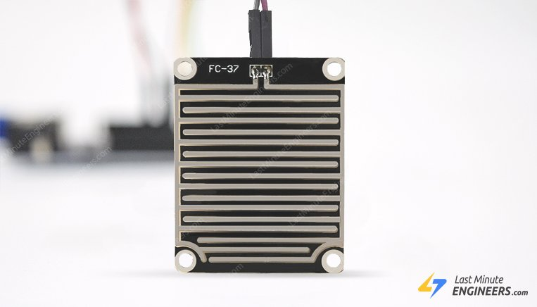

The rain sensor works on the principle of total internal reflection. It is used on the windshield of a car. When it rains, the wet glass causes the light to scatter and lesser amount of light gets reflected back to the sensor. When the water droplets hit the sensors it completes the circuit, producing sound from buzzer and turning the LEDs on.